**Drone Human Detection with Using Keyboard Control**

Cheung Tsz Chun Noddy 220171174

1. **Clearly show the objective of your project**

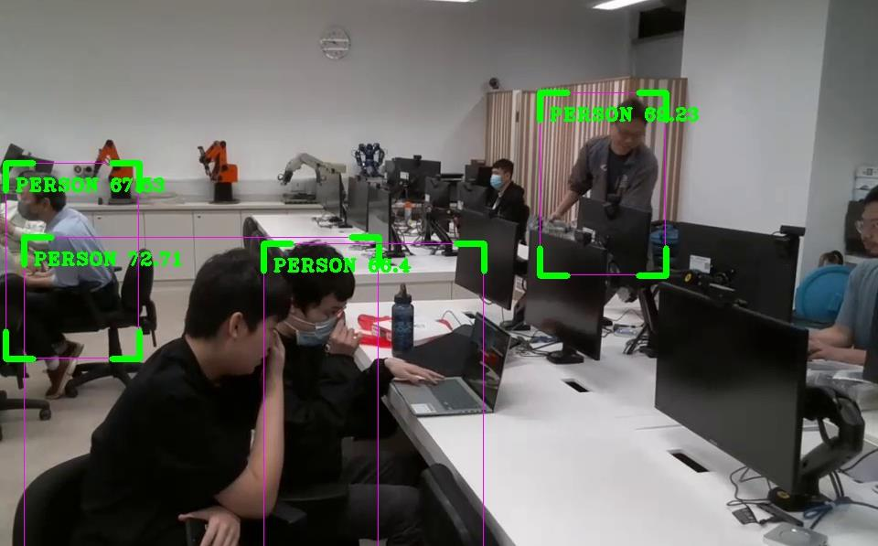

1. **Target users**

* Fire Services Department (FSD)
* Hong Kong St. John Ambulance Brigade (SJA)
* National Search and Rescue Agency (NASRA)
* United States Coast Guard Search and Rescue

1. **Special features**

* Real-time video streaming
* Highlight the detected humans, create a beep sound if humans are detected
* Keyboard control of the drone
* Mapping and finding out the distance in meters
* Take photos with the drone and send them back to the computer
* can be easily customized to detect specific objects (including dogs and cats)

1. **Applications**

* Search and rescue: locate missing persons in remote or inaccessible areas
* Monitor: monitor large areas
* Others: detecting missing animals (like dogs and cats)

1. **Describe the method used and discuss why such method is selected**

* The code utilizes the 'pygame' library to initialize the keyboard controls, fly the drone, and take pictures, while also implementing YOLOV3 for object detection. Additionally, Python math and OpenCV are used for mapping the drone's movements on a 2D map. Finally, the 'winsound' library is used to generate a beep sound whenever a human is detected by the YOLOV3 object detection algorithm.

**Why YOLO is being used:**

* Speed: YOLO can process images and video frames at very high speeds
* Accuracy: high accuracy in detecting objects, including people
* Reliability: YOLO has been extensively tested and validated on large datasets, making it a reliable and trustworthy tool for object detection
* Flexibility: YOLO can be easily customized to detect specific objects(including dogs and cats)

**How to control:**

• 1. Connect to Drone Wi-Fi

• 2. Click the pygame window

• 3. press keyboard button to control

• 4. press the stop button to stop the program

|  |  |
| --- | --- |
| **Command** | **Drone Movement** |
| LEFT, RIGHT | left-right |
| Up, Down | forward-backward |
| “w”, ”s” | up-down |
| “a”, ”d” | yaw (rotation) movement |
| “q”, ”e” | Land, Takeoff |
| “z” | Take Pictures |

**Take photos with the drone and send them back to the computer**

• Taken photos will be sent back to your PC in the Images folder inside the Resources

folder

• The photos are named by time, so the name won’t get duplicated

• 0.25s per photo for the interval, preventing too many pictures taken at the same time

**Generate a beep noise**

• The code will alarm the rescue team every time the drone finds a person

• The frequency is 1000 HZ and the duration is 50 milliseconds

• It’s useful for searching for multiple people over a large area, as it can

be difficult for rescue teams to keep track of all the search results

**Mapping**

• Knowing the (X, Y) axis in meters by calculating the drone speed (15 cm/s)

• Record the drone search history, the keyboard-controlled movements in the code can help the drone navigate to specific locations where people have been detected, or move in a systematic pattern to cover a large search area. This can save time and effort for the rescue team, as they can focus on analyzing the search results and planning their next steps, rather than manually controlling the drone's movements.

• Help to locate missing persons

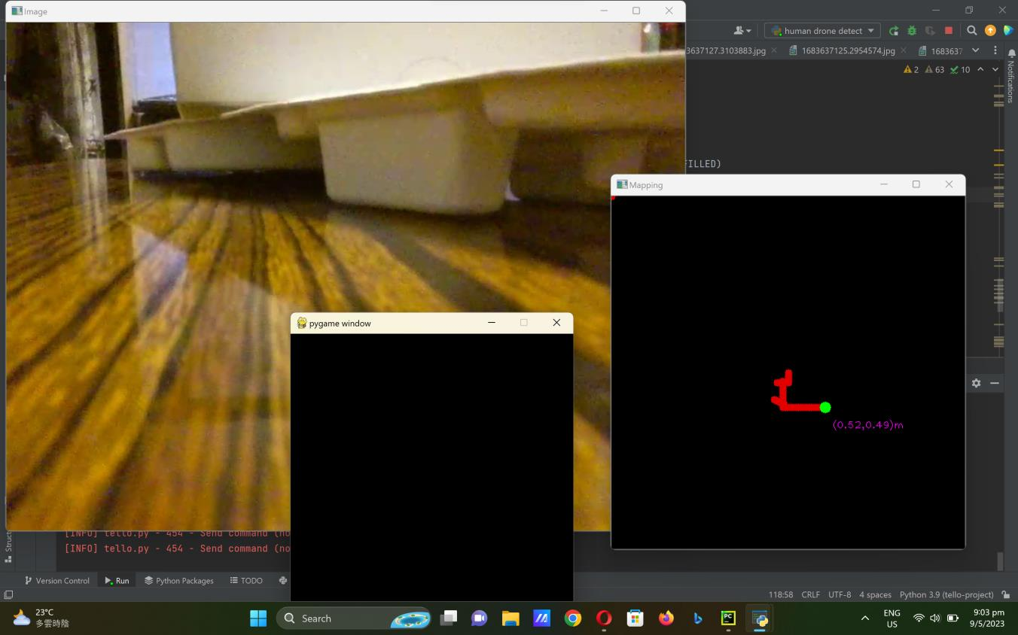

**Detect other objects(like Dogs and cats)**

• We can select other objects to detect by simply changing classNames.index(‘Person’) in line 42

• It can help the rescue team search for missing pets in emergency situations



1. **Timeline of the project**

* Easter Holiday: Project planning and research
* 17/4: Hardware setup. Ask school and teacher to bellow the drone
* 24-25/4: coding the keyboard part
* 29-30/4,1/5: coding the YOLO part to detect human and write the PowerPoint
* 9-10/5: coding the Mapping part and final testing

1. **Suggest any limitations of your design**

* Accuracy: While YOLOv3 is a highly accurate object detection algorithm, it is not perfect and can sometimes misclassify objects or miss detections altogether. This can be particularly problematic in applications where high accuracy is critical, such as medical imaging or industrial automation.
* Processing power: YOLOv3 is a computationally intensive algorithm, and running it on a low-powered device like a Tello drone can be challenging. This can lead to slower processing times and reduced frame rates, which can impact the real-time performance of the system.
* Limited range: The Tello drone has a limited range of approximately 100 meters, which can be a limitation in applications that require long-range surveillance or monitoring.
* Battery life: The Tello drone has a relatively short battery life of approximately 13 minutes, which can limit the amount of time it can be used for continuous surveillance or monitoring.
* Environmental factors: The performance of the Tello drone and YOLOv4 object detection algorithm can be impacted by environmental factors like lighting conditions, weather, and obstacles in the environment. This can lead to reduced accuracy or complete failure of the system in certain conditions.
* Cost: The cost of the Tello drone and any additional hardware or software required for the system can be a limitation for some applications, particularly those with limited budgets.

1. **Suggest any improvement that can be done in future**

* Hardware upgrades: Upgrading the hardware, such as using a more powerful drone or a more powerful computer, can improve the processing speed and performance of the system.
* Algorithm optimization: Optimizing the YOLOv4 algorithm for the specific use case can improve its performance and accuracy. This can involve fine-tuning the hyperparameters, adjusting the training data, or using pre-trained models.
* Integration with other technologies: Integrating the system with other technologies, such as machine learning, artificial intelligence, or robotics, can extend its capabilities and improve its performance.
* Multi-camera setup: Using multiple cameras can increase the coverage area of the system and improve its accuracy by providing more data points for object detection.
* Environmental monitoring: Incorporating sensors or other technologies to monitor environmental factors, such as lighting conditions and weather, can improve the performance of the system in different environments.
* Battery life extension: Using external battery packs or optimizing the power consumption of the system can extend the battery life of the Tello drone and enable longer surveillance or monitoring periods.
* User interface improvements: Improving the user interface of the system, such as using a graphical user interface or voice commands, can make it easier to use and more accessible to a wider range of users.
* Set up a Wi-Fi range extender: it can be set up to increase the coverage area of the drone and allow it to search larger areas.

1. **Discuss ethical issue**

* Privacy concerns: The use of a drone equipped with object detection technology could raise concerns about privacy, particularly if the drone is used for surveillance or monitoring purposes. It is important to ensure that the system is used in a way that respects individual privacy rights and complies with applicable laws and regulations.
* Bias and discrimination: Object detection algorithms like YOLOv4 can be susceptible to bias and discrimination, particularly if the training data is not diverse or representative of the population. It is important to ensure that the system is designed and implemented in a way that minimizes the risk of bias and discrimination.
* Safety risks: The use of a drone for surveillance or monitoring purposes could pose safety risks, particularly if the drone is flown in crowded or restricted areas. It is important to ensure that the system is used in a way that prioritizes safety and minimizes risks to people and property.
* Data security: The system may collect and store sensitive data, such as video footage and personal information. It is important to ensure that the data is stored securely and protected from unauthorized access or use.
* Unintended consequences: The use of a drone equipped with object detection technology could have unintended consequences, such as negative impacts on wildlife or unintended surveillance of individuals. It is important to consider the potential unintended consequences of the system and take steps to mitigate any negative impacts.